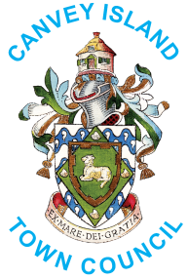

King’s Coronation – Best School Display

COMPETITION ENTRY FORM

Please complete the following in block capitals as follows:

School Name and Address: ...……………………………………………………..……........................................

...………............……………………………………………..…….........................................................

................................................................................................Postcode ....................................

Telephone Number: ............................................Email address: .................................................

Please give a description of your Coronation school display:

...……………………………………………………..……........................................................................
...……………………………………………………..……........................................................................
...……………………………………………………..……........................................................................
...……………………………………………………..……........................................................................
...……………………………………………………..……........................................................................

Why should your school win?

...……………………………………………………..……........................................................................
...……………………………………………………..……........................................................................
...……………………………………………………..……........................................................................
...……………………………………………………..……........................................................................
...……………………………………………………..……........................................................................

Judging will take place the week commencing 1st May 2023, where the Town Mayor and Deputy Town Mayor will visit your school and view the display. Should there be any dates you would not be available please let us know.

The winning school will be photographed and a press release issued to the local press. Please sign this form to say that if chosen, you would agree to take part in the publicity.

Signature: …………………………................................Date: ………………...................……..........…

Thank you for entering our Canvey Island King’s Coronation Best School Display Competition.
Good luck with your entry.

Please return your completed form by
Friday, 21st April 2023
to the Town Council office at 11 High Street, Canvey Island, SS8 7RB or events@canveyisland-tc.gov.uk

